Press Release, July 7, 2015
Works in Progress Award 2015
AWARD OF 10,000 EUROS IN SERVICES FOR THE MOST PROMISING PROJECT
15 projects selected out of 57 were presented at Karlovy Vary IFF’s Works in Progress 2015 on July 6. The international jury has selected the most promising project which will receive the award of 10,000 Euros in services from the event’s partner Barrandov Studios.
The award for the most promising project 2015 goes to:
PARK
dir. Sofia Exarchou, Greece
the project was presented by: Sofia Exarhou (director), Amanda Livanou (producer)
Statement of the Jury:
Set in the ruins of past glory, this film takes us to the bottom of society and ignites a firework of raw energy.
A portrayal of a young generation that has been betrayed and deprived of its future.
The Jury:
Paz Lázaro, Berlin International Film Festival (Germany)
Titus Kreyenberg, unafilm (Germany)
Jan Naszewski, New Europe Film Sales (Poland)

PARK
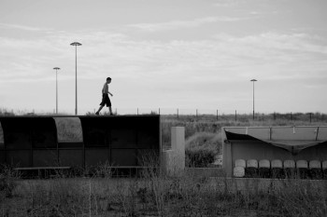
Greece
Directed by: Sofia Exarchou
Scriptwriter: Sofia Exarchou
Producer: Amanda Livanou, Christos V. Konstantakopoulos
Camera: Monika Lenczewska
Language: Greek, English
Genre: drama
Release date: 2016
What’s missing: sales agent, festival premiere, Polish associate for assistance with post-production funding
This film is director's debut.
This is the film's final distribution title.
Working version of the film will be presented.

Film synopsis
Ten years have passed, and the Olympic Village in Athens, Greece is in decay. Among the abandoned athletic facilities and new-money tourist resorts nearby, Dimitris (17), Anna (24), a retired athlete, and their friends traverse Greece’s “glorious” past with the decadence of today, creating a portrait of a society unprepared for the brutal fall.

Director’s filmography
Sofia Exarchou is the writer/director of the short films Mesecina and Distance. She pursued post-graduate studies in Toulouse and at the Stella Adler Studio in New York. Exarchou is based in Athens, where she received degrees in Electrical Engineering and Film studies.
In 2012, she began writing her first feature Park, which has already won multiple international development awards (Crossroads CNC Development Prize, Thessaloniki 2012, Eurimages Development Award, Sarajevo 2013). Park was selected both for the Sundance Screenwriter’s Lab & Director’s Lab (January & June 2014), the only European project in the year’s selection.

Producer’s filmography
Born in Athens, Amanda Livanou graduated from the London School of Economics with an MA in International History. She has been working as an independent film and television producer since 2000. Recent titles include L by Babis Makridis (World Drama Competition, Sundance Film Festival, Competition Rotterdam FF 2012, Grand Prix, Modolist FF), They Glow in the Dark (2013) by Panagiotis Evangelidis (Fipresci Award, Thessaloniki Doc Festival, Best Documentary, Hellenic Film Academy Awards). Curently in pre-production is Pity, by Babis Makridis, and the new documentary by Panagiotis Evangelidis. She is a graduate of the EAVE Producers training program (1997). She was elected to the Board of Directors of Directors of the Hellenic Film Academy in 2013.

Contact / Presenters

NEDA Film
35, Dervenion str., 10681, Athens, Greece
Email: info@nedafilm.gr
www www.nedafilm.gr

Faliro House Productions
8A Pentelis Street, 17564, Athens - Palaio Faliro, Greece
Email: info@falirohouse.com
www www.falirohouse.com


Amanda Livanou | Producer
Email: amanda@bebenfilms.com
Mobile: + 30 6944 757339

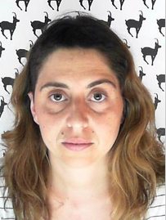
Sofia Exarhou | Director, Scriptwriter
Email: sofexar@yahoo.com

