Organizer of the 51st Karlovy Vary IFF 2016: Film Servis Festival Karlovy Vary, a.s.

Organizers of the 51st Karlovy Vary IFF thanks to all partners which help to organize the festival.

51st Karlovy Vary IFF is supported by:
Ministry of Culture Czech Republic

General partner: CEZ Group

Main partners: Vodafone Czech Republic a.s.

RWE

Pivovary Lobkowicz Group

City of Karlovy Vary

Karlovy Vary Region
Partners: UniCredit Bank Czech Republic and Slovakia, a.s.
UNIPETROL, a.s.
KKCG investment group
construction group EUROVIA CS
Official insurer: Allianz Insurance
Official car: BMW
Official beverage: Karlovarská Korunní
In cooperation with: CzechTourism, Ministry of Regional Development
Official champagne: Moët & Chandon
Official coffee: Nespresso
Official drink: Finlandia Vodka
Official make-up artist: Douglas
Official Fest Food: Bageterie Boulevard
International shipping partner: DHL Express (Czech Republic), s.r.o.
Main media partners: Czech Television
Czech Radio Radiožurnál
PRÁVO
Novinky.cz
REFLEX
Media partners: JCDecaux Group
ELLE Magazine
magazine TV Star
Radio 1
DOTYK Magazine
Festival awards supplier: MOSER, a.s.
Supplier: JT International spol. s r.o.
Hardware supplier: Fujitsu
Consumer electronics supplier: LG Electronics
Software solutions: Microsoft
Partner of the festival Instagram: SWISSDENT Dental Cosmetics
Main hotel partners: SPA HOTEL THERMAL
Grandhotel Pupp
Augustine, a Luxury Collection Hotel, Prague
Partner of the People Next Door section: Sirius Foundation
Partner of the No Barriers Project: RWE Energie
Partner of the Industry Pool: Barrandov Studio
Wine supplier: Víno Marcinčák
GPS technology supplier: ECS Invention spol. s r.o.
Official bike: Specialized
Supplier: Air Navigation Services of the Czech Republic

KARLOVY VARY FILM FESTIVAL TO HONOUR ACTOR WILLEM DAFOE
The Crystal Globe for Outstanding Contribution to World Cinema at the 51st Karlovy Vary International Film Festival will be presented to leading film and theatre actor and two-time Oscar nominee Willem Dafoe.
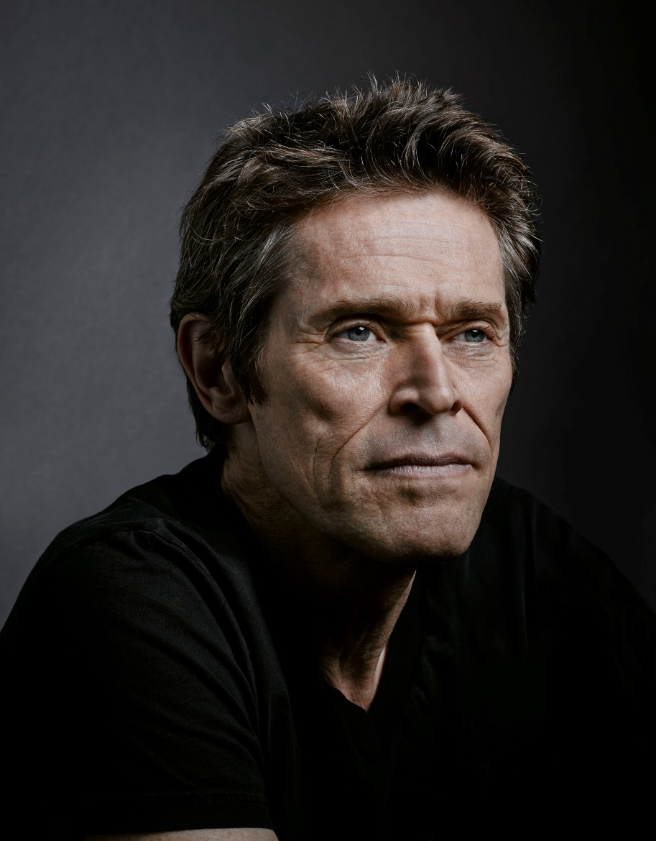
In 1979, Willem Dafoe was given a small role in Michael Cimino's Heaven's Gate from which he was fired. His first feature role came shortly after in Kathryn Bigelow's The Loveless. From there, he has gone on to perform in over 100 films - in Hollywood (John Carter, Spider-Man, The English Patient, Finding Nemo, Once Upon A Time In Mexico, Clear And Present Danger, White Sands, Mississippi Burning, Streets Of Fire, American Dreamz), independent U.S. cinema (Out of The Furnace, The Fault in Our Stars, Bad Country, John Wick,The Clearing, Animal Factory, The Boondock Saints, American Psycho), and abroad (Theo Angelopoulos’ The Dust Of Time, Yim Ho's Pavilion Of Women, Yurek Bogayevicz's Edges Of The Lord, Wim Wenders' Faraway, So Close, Nobuhiro Suwa's segment of Paris Je t'aime, Brian Gilbert's Tom & Viv, Christian Carion's Farewell, The Spierig Brothers’ Daybreakers, Daniel Nettheim's The Hunter, Anton Corbijn’s A Most Wanted Man and the international box-office hit Mr. Bean's Holiday).
Photo credit: Brad Trent
He selects projects based on the diversity of roles and opportunities to work with strong directors. He worked in the films of Wes Anderson (The Life Aquatic, The Grand Budapest Hotel, and The Fantastic Mr. Fox), Martin Scorsese (The Aviator, The Last Temptation Of Christ), Spike Lee (Inside Man), Julian Schnabel (Miral, Basquiat), Paul Schrader (Auto Focus, Affliction, Light Sleeper, The Walker, Adam Resurrected, Dog Eat Dog), David Cronenberg (Existenz), Abel Ferrara (Pasolini, 4:44: The Last Day On Earth, Go Go Tales, New Rose Hotel), David Lynch (Wild At Heart), William Friedkin (To Live And Die In LA), Werner Herzog (My Son, My Son, What Have Ye Done), Oliver Stone (Born On The Fourth Of July, Platoon), Giada Colagrande (A Woman, Before It Had A Name), and Lars von Trier (Antichrist, Manderlay, and Nymphomaniac I & II).
He was twice nominated for an Academy Award (Platoon and Shadow Of The Vampire) and once for a Golden Globe. Among other nominations and awards, he received an LA Film Critics Award and an Independent Spirit Award.
Upcoming films include Yimou Zhang’s The Great Wall, Pixar’s Finding Dory, Tommy Wirkola’s What Happened to Monday?, Mark Williams’ The Headhunter’s Calling and Paul Schrader's Dog Eat Dog.
Dafoe is one of the founding members of The Wooster Group, the New York based experimental theatre collective. He created and performed in all of the group's work from 1977 thru 2005, both in the U.S. and internationally. Since then, he worked with Richard Foreman in Idiot Savant at The Public Theatre (NYC) and most recently two international productions with Robert Wilson: The Life & Death of Marina Abramovic and The Old Woman opposite Mikhail Baryshnikov.
In honour of Willem Dafoe, the Karlovy Vary film festival will show the film Pasolini by Abel Ferrara (July, 2nd 10.30 p.m. Thermal, Grand Hall) and Martin Scorese´s The Last Temptation of Christ (July, 3th 11 p.m. Outdoor Cinema).

KARLOVY VARY FESTIVAL TO HONOUR OSCAR-WINNING SCREENWRITER CHARLIE KAUFMAN
The President’s Award at this year’s Karlovy Vary International Film Festival will be presented to and personally received by screenwriter, director and producer Charlie Kaufman, who won an Oscar for his script for Eternal Sunshine of the Spotless Mind.
Charlie Kaufman is considered one of today’s most interesting original filmmakers. After spending several years working on television series, Kaufman literally stunned audiences with his original screenplay for Being John Malkovich (1999), the directorial debut of Spike Jonze. The screenplay earned Kaufman nominations for an Oscar and a Golden Globe, plus a BAFTA Award for Best Original Screenplay.
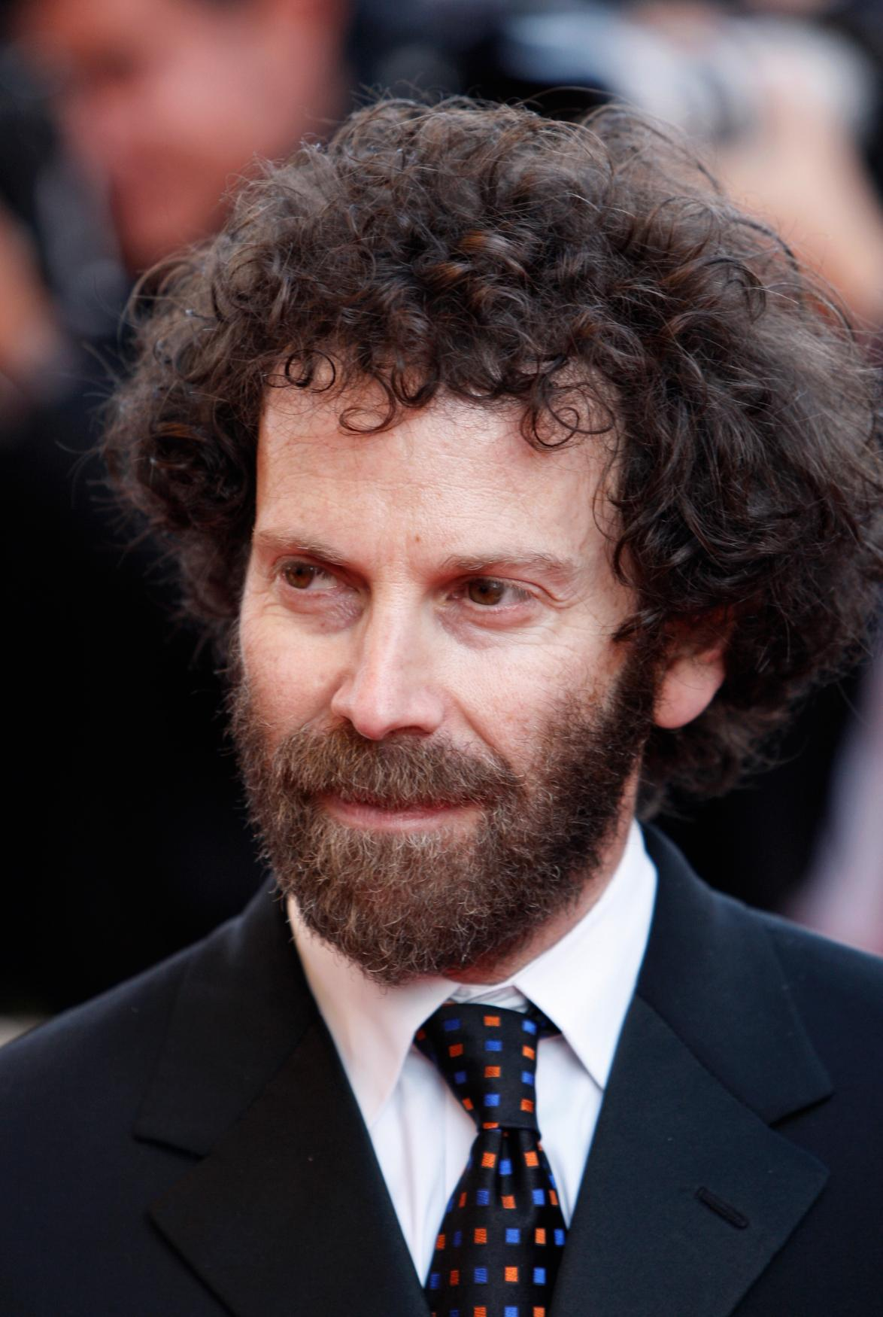
He later wrote Human Nature (2001), which was directed by another talented director, Michel Gondry. This was followed by the screenplay to George Clooney’s directorial debut Confession of a Dangerous Mind (2002). Also that year, he teamed up with Spike Jonze again for Adaptation. The film, a partially autobiographical look at a screenwriter suffering from writer’s block while trying to adapt Susan Orlean’s book The Orchid Thief, literally amazed audiences and critics and earned Kaufmann another Oscar and Golden Globe nomination, as well as another BAFTA Award. His subsequent film Eternal Sunshine of the Spotless Mind (2004), directed by Michel Gondry, was met by a literal tidal wave of enthusiasm. The screenplay, which like his first film explores the subject of controlling people’s thoughts, won an Oscar and a BAFTA Award. Altogether, the film earned more than 60 awards.
Photo: Photograph cannot be redistributed or published without consent of ČTK.

In 2008, Charlie Kaufman had his directorial debut with Synecdoche, New York, for which he wrote the screenplay as well. The film was shown at the Cannes Film Festival. The latest addition to his highly diverse and original filmography is Oscar nominated Anomalisa (2015), which will be screened in his honour at this year’s Karlovy Vary IFF.

KARLOVY VARY IFF WILL OPEN WITH WORLD PREMIERE OF ANTHROPOID
The opening ceremony of the Karlovy Vary IFF will include the gala world premiere of Anthropoid attended by a large filmmakers delegation. The film will be presented by actors Jamie Dornan and Toby Jones, Aňa Geislerová, Alena Mihulová, Václav Neužil and Marcin Dorocinski and screenwriter and director Sean Ellis.

Sean Ellis
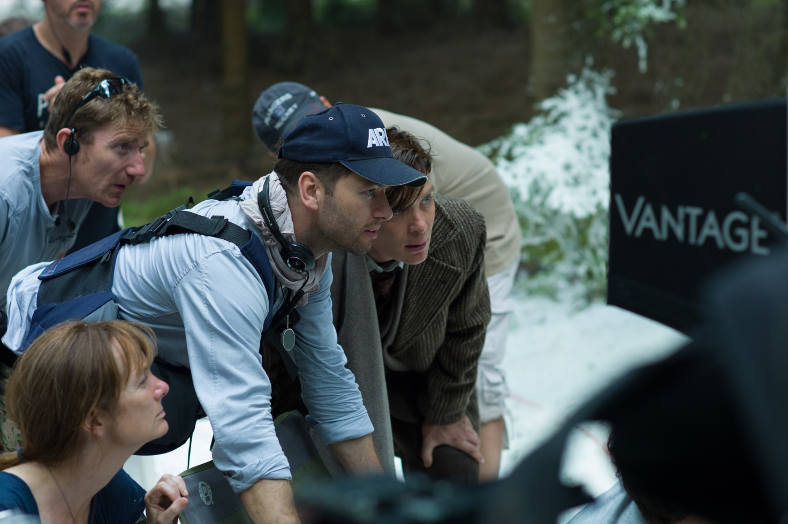
British director and screenwriter Sean Ellis made his name with Cashback (2004), a comedic short set during the night shift at a supermarket which each employee deals with in his own way. Two years later the Oscar-nominated short became the basis for a feature-length film of the same name. Ellis’ next film was the horror drama The Broken (2008), a few years after which he surprised his fans again with the sophisticated social drama Metro Manila (2013).

Jamie Dornan
Northern Irish actor Jamie Dornan most recently starred as the lead, Christian Grey, in the much anticipated feature film Fifty Shades of Grey. Grossing over $550M worldwide, the film’s release marked the biggest opening weekend for an R-rated title internationally. In television, Dornan received critical acclaim for his portrayal of a chilling serial killer in Netflix/BBC's The Fall, the third series of which will air in 2016. He has also starred in Channel 4’s New Worlds and ABC's Once Upon A Time. Upcoming film releases include The 9th Life Of Louis Drax and Jadotville, in addition to the next instalments of the Fifty Shades trilogy: Fifty Shades Darker and Fifty Shades Freed. In the film Anthropoid, which deals with the dramatic events around the assassination of Reinhard Heydrich, Dornan played the role of one of the paratroopers, Jan Kubiš.
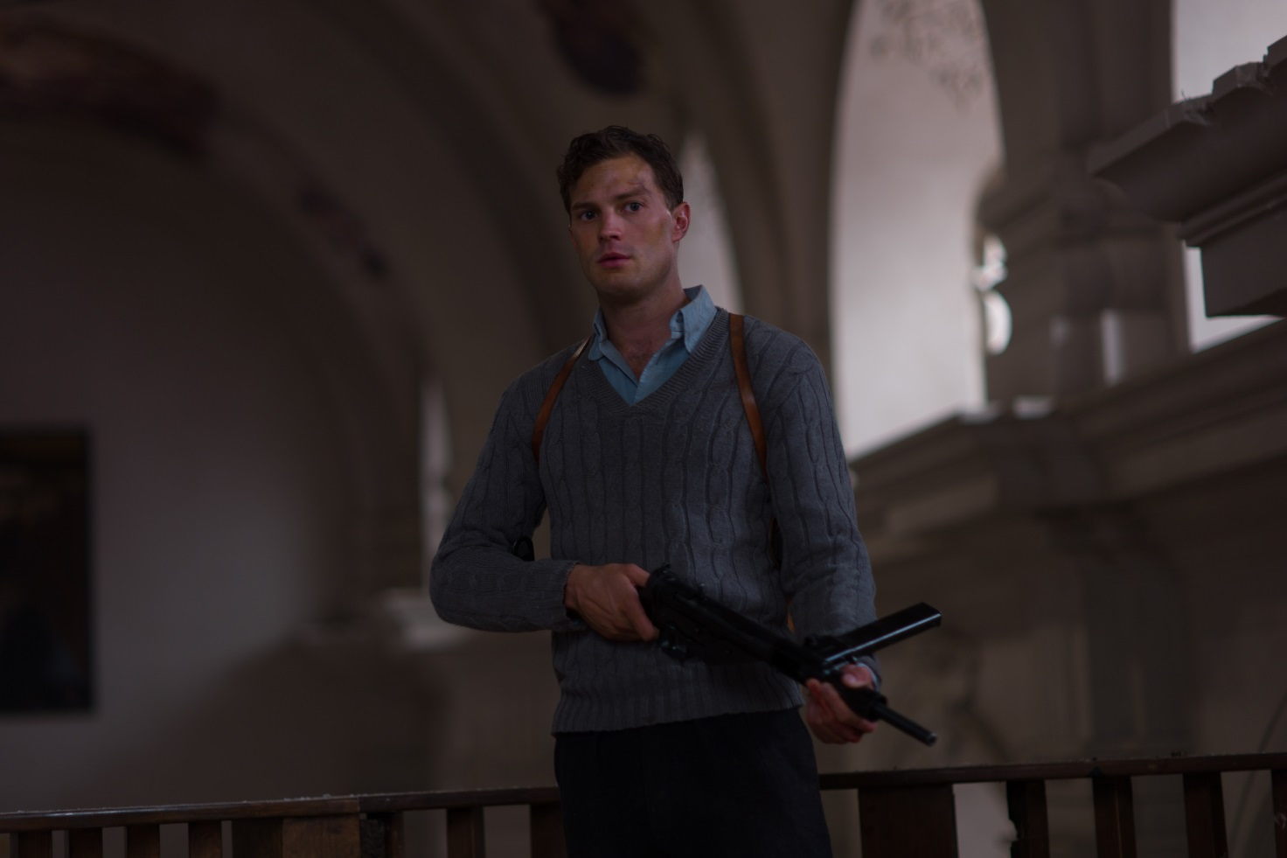

Toby Jones
In Anthropoid, Jones played the role of Jan Zelenka-Hajský, the leader of a radical resistance group who worked with the parachutists and helped them find hiding places.

Toby Jones began his film career in 1992 with a part in Sally Potter’s Orlando. Since then, he has become one of the most distinguished film, television and stage actors of his generation.

For his portrayal of Truman Capote in Infamous (2006) he won a London Critics’ Circle Film Award – an achievement he repeated with his performance in director Peter Strickland’s Berberian Sound Studio (2012).

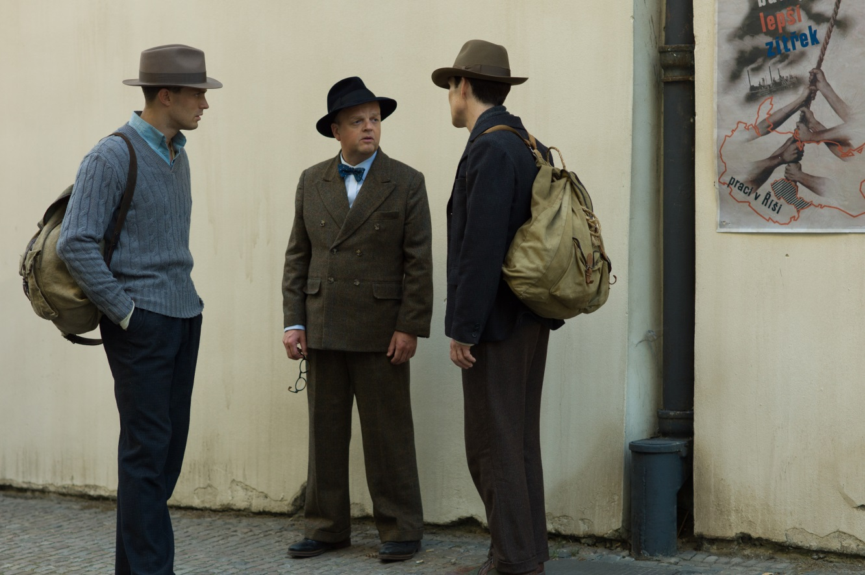

Jones was also nominated for a BAFTA in 2015 for his turn in the multi-award winning BBC TWO film for television Marvellous and nominated for a Golden Globe, an EMMY and a BAFTA when he starred as the lead and famous filmmaker, ‘Alfred Hitchcock’ in The Girl for HBO and the BBC in 2013.

Toby’s further film credits include Ron Howard’s period drama Frost/Nixon (2008), as well as box-office hits such as The Hunger Games series and the action sci-fi Captain America: The First Avenger (2011) and Captain America: The Winter Soldier (2014).

For theatre, Toby was awarded the 2002 Laurence Olivier Theatre Award for ‘Best Actor in a Supporting Role’ for his performance in The Play What I Wrote, a musical farce written by Hamish McColl, Sean Foley and Eddie Braben, and directed by Kenneth Branagh. Toby has also starred as ‘Arthur’ at the Wyndham Theatre, London before the play opened on Broadway, New York where it was nominated for a Tony as Best Entertainment.

ACTRESSES ADRIANA UGARTE AND EMMA SUÁREZ PRESENT THE LATEST FILM BY PEDRO ALMODÓVAR, JULIETA
In this year’s non-competition section Horizons, the Karlovy Vary IFF will be screening the newest film by director Pedro Almodóvar, Julieta. The screening will be attended by the two actresses who play the film’s title role, Adriana Ugarte and Emma Suárez.
“Julieta marks my return to the female universe,” says director Pedro Almodóvar. “One of the risks I faced from the beginning was that of using two different actresses for Julieta. Adriana Ugarte from twenty five to forty, and Emma Suárez from forty onward. I’m not in favor of the same actress playing all the ages of the same character. I don’t trust the effects of make-up for aging, and it’s almost impossible for a young woman of twenty five to have the presence of someone of fifty. It isn’t a matter of wrinkles, it’s something more profound, the passing of time, on the outside and on the inside,” emphasizes Pedro Almodóvar and adds. “Now I’m happy about having taken that decision. And I think that Adriana Ugarte and Emma Suárez now form part of my particular Olympus where they rub shoulders with Penélope Cruz, Carmen Maura, Victoria Abril, Marisa Paredes and Cecilia Roth, my muses.”
Madrid native Adriana Ugarte comes from an artistic family and her grandfather was a close collaborator of famous director Luis Buñuel. She began her acting career in television series and small-scale movies, and by the time she was 23 she had been nominated for a Goya Award for best young actress. Soon thereafter, she gained a wider following through her role in the series La Señora. Working with Pedro Almodóvar is another important milestone in her career.
Emma Suárez has a long and varied career behind her that began when she was 15 years old. She has made dozens of movies and television series, and has worked with leading Spanish directors such as Julio Médem (Cows, The Red Squirrel, Earth) and Agustí Vila, who directed her in The Mosquito Net (La Mosquitera), which won the Crystal Globe for best film at the 2010 Karlovy Vary IFF.
At the 51st KVIFF, Emma Suárez will present not only Pedro Almodóvar’s Julieta, but also the competition film The Next Skin (La propera pell), directed by Isaki Lacuesta and Isa Campo.

CÉSAR-WINNING SPANISH ACTOR SERGI LÓPEZ TO PRESENT THE NEXT SKIN AT KVIFF
Spanish movie actor Sergi López will join actress Emma Suárez in Karlovy Vary for the screening of directors Isaki Lacuesta and Isa Campo’s The Next Skin (La propera pell), which is being shown in main competition at the 51st KVIFF.
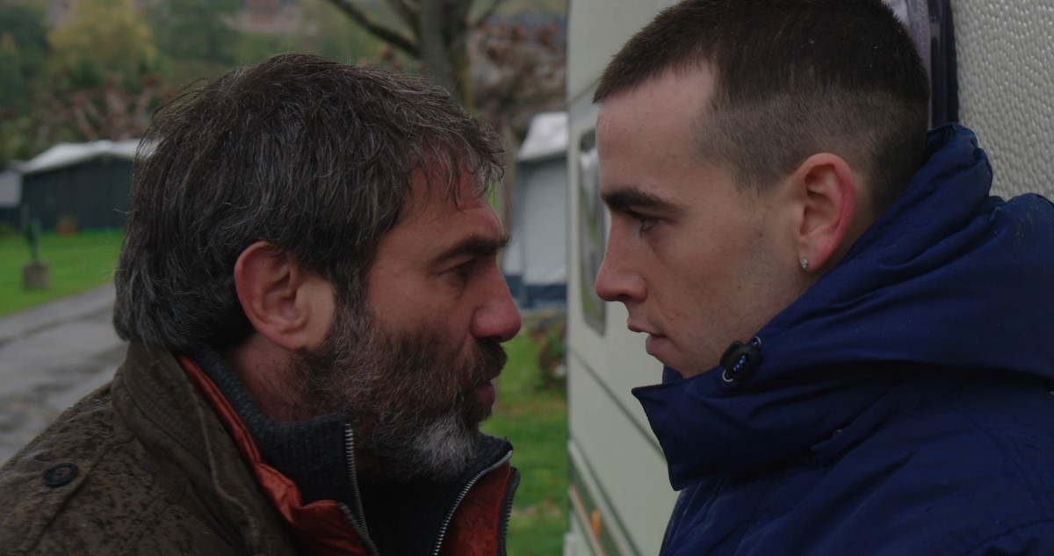
Sergi López hails from Barcelona, but he began his acting career in Paris with the main role in French director Manuel Poirier’s La petite amie d’Antonio (1991). López and Poirier worked together on several occasions; their biggest international success was Western (1997), which won the Jury Prize at the Cannes Film Festival and was nominated for several Césars. Sergi López’s next international success was with Frédéric Fonteyne’s love story An Affair of Love (Une liaison pornographique, 1999), for which both main actors – López and Nathalie Baye – took home best actor awards from the Venice International Film Festival. The following year, Sergi López shone in the title role of Dominik Moll’s Harry, He’s Here to Help (Harry, una mi qui vous veut du bien), for which he won a César and a European Film Award. The film was also nominated for a BAFTA. Soon after, he appeared in Stephen Frears’s critically acclaimed Dirty Pretty Things (2002). In 2006, he played the role of Captain Vidal in Guillermo del Toro’s mysterious drama Pan’s Labyrinth (El Laberinto del Fauno, 2006). Although he declared that it was the most hideous role of his life, the film won three Oscars in technical categories, a BAFTA Award for Best Film Not in the English Language, and several dozen other international awards. López continues to develop his multifaceted European cinematic acting career in films such as Leaving (Partir, 2009), The Monk (Le Moine, 2011) Tango libre (2012) and Tenderness (La tendresse, 2013) – these two were shown at the Karlovy Vary IFF – and the drama A Perfect Day (2015).

GERMAN ACTOR ULRICH TUKUR TO PRESENT COMPETITION FILM ORIGINAL BLISS
Leading German film and theatre actor Ulrich Tukur will appear at the 51st KVIFF to present Sven Taddicken’s Original Bliss (Gleißendes Glück , 2016), which is being shown in competition at the festival.
Tukur began his acting career at the theatre in Heidelberg, after which he spent several years with the Deutsches Schauspielhaus in Hamburg, where he worked with leading directors such as Peter Zadek. In 1986, "Theater heute" magazine named him actor of the year.
He launched his film career in the 1980s with a role in Michael Verhoeven’s The White Rose (Die weiße Rose, 1982). Over the years, he has appeared in numerous television films and series, including the popular police drama Crime Scene (Tatort).
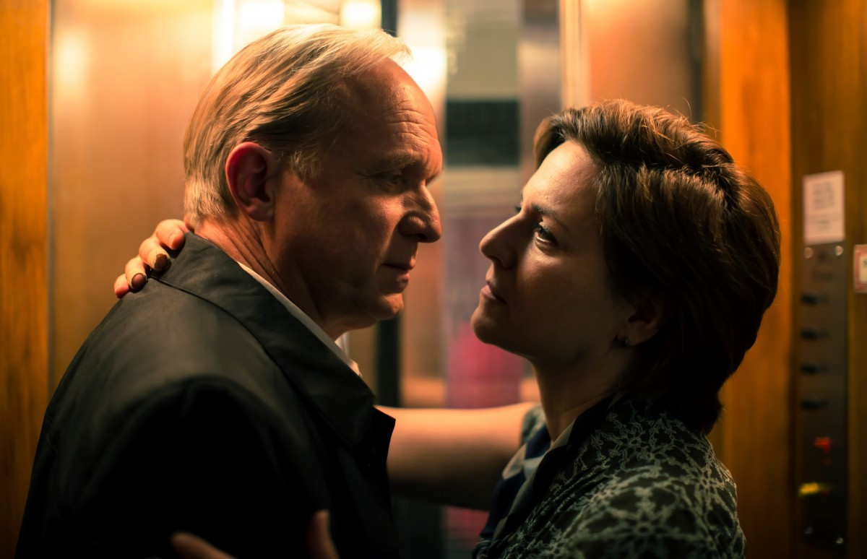
In 2006, he played one of the main roles in The Lives of Others (Das Leben der Anderen), which won the Oscar for Best Foreign Language Film. He also played one of the leads in Michael Haneke’s drama The White Ribbon ( Das weiße Band – Eine deutsche Kindergeschichte, 2009), which won the Golden Palm at the Cannes Film Festival, a Golden Globe for Best Foreign Language Film, and received two Oscar nominations. Tukur could last be seen at the Karlovy Vary International Film Festival in Bastian Günther’s Houston (2013).

INTERNATIONAL JURIES

Statutory Juries:

Grand Jury

Maurizio Braucci
The Italian novelist and screenwriter first came to cultural attention with the novel Il mare guasto, which was also translated into French. As scripter he is co-creator of Matteo Garrone’s Gomorrah (2008) and Reality Show (2012), Abel Ferrara’s Napoli Napoli Napoli (2009) and Pasolini (2014), The Interval (2012) by Leonardo Di Costanzo, Tatanka (2010) by Giuseppe Gagliardi, Francesco Munzi’s Black Souls (2014), and Lost and Beautiful (2015) by Pietro Marcello. Gomorrah brought him awards domestically and from the European Film Academy, as well as a prize from the Chicago IFF. His work on Black Souls earned honors from the Italian Academy and local journalists. In Napoli, where he was born and still lives, he is actively engaged in the organization of social projects for underprivileged kids, in part through his work as art director of the Arrevuoto – Theater and Pedagogy project.
Eve Gabereau
Cofounder and managing director of Soda Pictures, an Anglo-Canadian film distributor with a solid library of over 300 titles picked up since 2002. With the aim of expanding their UK business and of building a North American division, the firm merged with the Thunderbird Films media group. In her role at Soda she is involved in production projects, producer relations, acquisitions, and overall release strategies. Soda Pictures recent distribution activities include Grímur Hákonarson’s Rams, Alice Winocour’s Disorder, and Joachim Trier’s Louder Than Bombs. They are currently bringing the popular and critical Cannes hits Paterson (dir. Jim Jarmusch) and Toni Erdmann (dir. Maren Ade) to British theaters.
Martha Issová
Czech film and theater actress. She chose an acting career at age four thanks to her mother-actress, who brought her to a theater audition for a surrealist play. Her father-director instilled in her a love of film, and in 1999, at age 16, she debuted in Karel Kachyňa’s Hanele. Since then she has appeared in numerous films, including The Conception of My Younger Brother (2000), The Beginning of the World (2000), and a quartet of Alice Nellis films: Some Secrets (2007), Mamas & Papas (2010), Perfect Days (2011), and The Seven Ravens (2014). Night Owls (2008, dir. Michaela Pavlátová) brought her the Best Actress Crystal Globe at KVIFF, and she has been thrice nominated for a Czech Lion. She tries to be a good mother, partner, and artist; it may take a lot of effort but she believes it’s worth it.
George Ovashvili
The Georgian director graduated from the Georgian State Institute of Cinema and Theater (1996) and attended a course at the Hollywood branch of the New York Film Academy (2006). He has directed a number of poignantly elegant shorts, including Wagonette (1996) and Eye Level… (2005), awarded at Berlin. In 2009 his feature debut The Other Bank screened in the East of the West Competition at KVIFF; while making the rounds of more than 100 festivals, the work picked up roughly 50 awards. His second feature effort Corn Island (2014) garnered the Crystal Globe for Best Film at the 49th Karlovy Vary IFF and was shortlisted among nine films vying for the Best Foreign Language Film Oscar. At present he is finishing up his latest movie Khibula and is in preproduction on The Pass.
Jay Van Hoy
An American producer who graduated from the University of Texas at Austin. He has been a longtime advisor at the Sundance Institute Creative Producing Lab, a participant in the creation of the Catalyst program at Sundance, and a mentor for the Cinetrust mentorship program at Cinereach. In 2004 he and Lars Knudsen founded Parts & Labor, a production company dedicated to director-driven pictures. He was instrumental in bringing out Mike Mills’ Oscar winning Beginners (2010), Julia Loktev’s The Loneliest Planet (2011), David Lowery’s Ain’t Them Bodies Saints (2013), Kelly Reichardt’s Old Joy (2006) and Ira Sachs’ Keep the Lights On (2012) and Love Is Strange (2014). He produced The Witch by Robert Eggers (2015), Complete Unknown by Joshua Marston (2016), and participated in the creation of this year’s Cannes favorite American Honey from Andrea Arnold.

East of the West Jury

Carmen Gray
Film critic and journalist. She was born in New Zealand and lives in Berlin. She writes for The Guardian, The Observer, Sight & Sound, Screen, The Calvert Journal, Senses of Cinema, and Sirp, an Estonian cultural weekly. She is the former editor of Dazed & Confused magazine and was also a programmer for the film education charity Filmclub UK. She is currently on the Berlin Critics’ Week selection committee and holds creative writing workshops for young film critics at the festivals in Warsaw, Tallinn and Palić in Serbia.
Tolga Karaçelik
Turkish director and screenwriter, creator of award-winning feature and short films. His feature debut Toll Booth (2010) screened at numerous festivals, winning thirteen awards, including Best First Film, Best Actor and Best Cinematography at Turkey’s major festival Golden Orange. After its premiere at Sundance in 2015, Karaçelik’s second film Ivy was screened in last year’s KVIFF East of the West Competition and went on to tour more than thirty festivals, securing over twenty awards. He is currently working on his next film, Butterflies.
Mikuláš Novotný
Czech producer. He took a course in film production at Prague’s FAMU and during his studies he worked as a line producer primarily on feature films. He established the production company Background Films in 2011. The spiritual comedy Journey to Rome (2015), his debut in the role of feature-film producer, opened last year’s East of the West section at Karlovy Vary, where it competed as well. Mikuláš Novotný also supports emerging young artists through a Prague-based gallery which he runs with colleagues.
Agnieszka Smoczyńska
Polish film director. A graduate of culture studies and film direction at the University of Silesia in Katowice, she also attended masterclasses headed by Agnieszka Holland, Andrzej Wajda and Wojciech Marczewski at the Andrzej Wajda Master School of Film Directing. After a series of award-winning short features and documentaries she turned in her feature debut The Lure, which earned her Best Debut at Gdynia, Discovery of the Year at the Polish Film Awards, and the Special Jury Prize at Sundance for the film’s “Unique Vision and Design.”
Yoshi Yatabe
Japanese festival organiser. He attended Tokyo’s Waseda University and also studied in France. After eight years in the world of finance he began producing and distributing documentary films and also headed the French Film Festival in Tokyo. He joined the Tokyo International Film Festival in 2002 as programme coordinator and served as Programme Director for the Japanese independent film section. In 2007 he was appointed Programme Director for the international competition. He produced the documentary film Dryads in a Snow Valley by director Shigeru Kobayashi in 2015.

Documentary Film Jury

Sigrid Jonsson Dyekjær
Danish producer who has helped create more than twenty acclaimed documentary films since 2000. Arguably the most successful of these, Hanna Polak’s Something Better to Come (2014), received an Academy Award nomination and won over thirty prizes. She produced the documentary BUGS, presented this year at the Tribeca IFF, as well as Ai Weiwei – The Fake Case (2013). Later this year sees the premiere of Ulrich Seidl’s Safari, which Dyekjær coproduced. She often cooperates with female directors, among them Phie Ambo, Mikala Krogh, Pernilla Rose Grønkjær, and Eva Mulvad, whose film The Good Life (2010) was victorious in KVIFF’s Documentary Competition in 2011.
Hana Kulhánková
She graduated in English and American studies from the Faculty of Arts of Brno’s Masaryk University. She has worked for a number of film festivals, taught American avant-garde film history and gender and queer theory, and has been actively involved in LGBT+ advocacy. Since 2005 she has been with People in Need (Člověk v tísni), the organization where she currently manages the One World International Human Rights Documentary Film Festival, the largest human rights doc fest in the world.
Laurent Bécue-Renard
French director and producer. He wrote, directed, and produced the documentary War-Wearied (De guerre lasses), about the enduring impact the Yugoslav Wars have had on the lives of three widows. The picture, which took the Peace Film Award at the Berlinale, screened at dozens of festivals, including KVIFF 2001 where it took part in the Documentary Competition. Of Men and War, the second part of his Genealogy of Wrath trilogy, premiered in the Official Selection at Cannes in 2014; it also captured the main prize from IDFA, the largest doc fest, and picked up a European Film Academy nomination for best documentary.

Nonstatutory Juries:

FIPRESCI Jury
Mihai Chirilov
Ohad Landesman
Demetrios Matheou
Martina Vacková
Clementine Van Wijngaarden

Ecumenical Jury
Susanne Charlotte Knudstorp
Maria José Martinez
Joel Ruml
Stanislav Zeman

FEDEORA Jury
Dubravka Lakić
Ninos Feneck Mikelides
Michael Ranze

Europa Cinemas Label Jury
Jörg Jacob
Aiga Millere
Theodora Olivi
Samo Seničar

KARLOVY VARY FESTIVAL WILL HOST WORLD PRODUCER TED HOPE AND PAY TRIBUTE TO FRANK DANIEL
Ted Hope and Amazon Studios at KVIFF
The Karlovy Vary IFF is excited to welcome back Ted Hope, a renowned producer of independent films (e.g. 21 Grams, Happiness, American Splendor, and Storytelling) who is now representing Amazon Studios as Head of Motion Picture Production. Amazon has vigorously entered the film market in recent years with a new strategy for film production and distribution through its video-on-demand platform, while at the same time focusing on theatrical releases of independent art house films. Most recently, Amazon had five of its films selected for the Cannes festival and it continues to develop TV shows and movies via on-line submissions and feedback through crowd-sourcing.
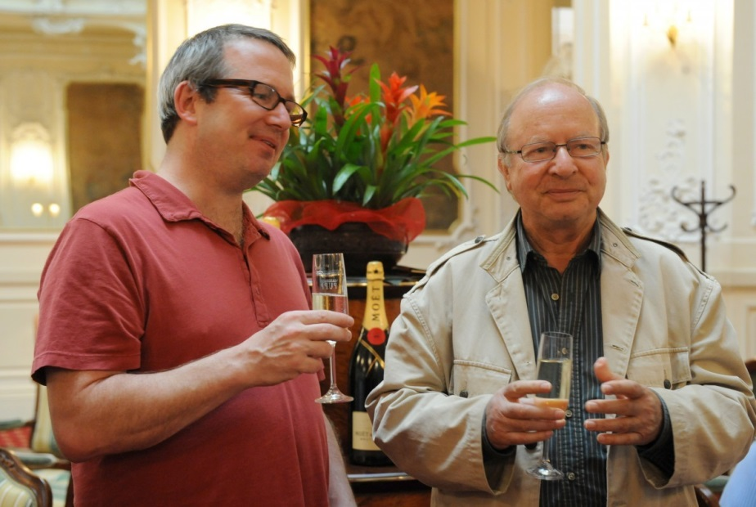
“Ted has already been to the festival twice – once as a member of the Main Jury and once as a producer of a competition film The Collaborator. When we met at Sundance this year, we agreed it would be wonderful to have him at Karlovy Vary as Amazon Studios’ chief producer so that this innovative project can be introduced in the Czech Republic. However, Ted would also like to use the unique opportunity to meet dozens of European distributors,” says the festival’s executive director Krystof Mucha.
In addition, the festival will organize a public industry event at which Ted will offer his fresh vision for film in the years to come.

A Frank Daniel Day
This year marks the 90th anniversary of the birth and the 20th anniversary of the death of Czech screenwriter, producer, director and outstanding film teacher František (Frank) Daniel (1926-1996). At “A Frank Daniel Day”, this year’s Karlovy Vary International Film Festival will remember one of the most widely respected filmmakers of Czech origin.
František Daniel significantly influenced modern Czech filmmaking through his work on nearly 40 Czechoslovak films as screenwriter, director, producer and the head of one of the most progressive production groups at Barrandov Studios. His most successful project was the Oscar-winning The Shop on Main Street (1965), on which he worked as a producer – a position he managed to push through despite the communist bureaucracy’s opposition.
Daniel first began teaching in the mid-1950s, and some of his most talented students included Pavel Juráček and Miloš Forman. In 1967–68 he was the dean of FAMU.
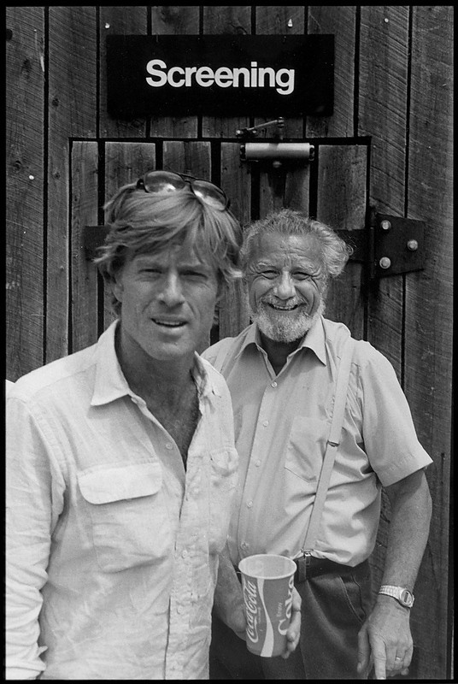
In 1969, Daniel emigrated to the United States, where he continued in his teaching activities. He was the first dean of the American Film Institute in Los Angeles, for which he developed an educational programme that was later adopted by many other schools. One of his students at AFI was the young director David Lynch, whom Daniel helped with the realization of his first film, Eraserhead. To this day, Lynch calls Daniel his mentor and the best film teacher in history, someone who had a fundamental influence on his career. After leaving AFI – a departure directly related to his support for Lynch – Daniel taught at Carleton College in Minnesota and at Columbia University in New York. In 1981, Robert Redford offered Daniel the position of artistic director for his new Sundance Institute. Daniel also helped to establish the screenwriting department at the University of Southern California and acted as a consultant for the Rockefeller Foundation and person consultant for David Rockefeller.
The Karlovy Vary festival will honour the extraordinary figure of František Daniel with an art workshop where his teaching methods will be presented by analysing the film Some Like It Hot.
The festival will also be showing Letos v září (1963), which he co-wrote and directed while still in Czechoslovakia. The screening will be preceded by an introductory talk. Guests include Daniel’s long-time friend, the director Ivan Passer, his sons Martin (who is also a film teacher) and Michal (a photographer), and Ted Braun.
The media partner of A Day with Frank Daniel is also the festival’s main media partner, Reflex magazine.

